**JSX, ES6, Virtual DOM, Reconciliation, React Fiber, Props, Index vs Keys, Config Driven UI**

1. **Is JSX mandatory for React JS?**

JSX allows us to write HTML elements in JavaScript and place them in the DOM without any createElement() and/or appendChild() methods. JSX converts HTML tags into react elements. You are not required to use JSX, but **JSX makes it easier to write React applications**.

2. **Is es6 mandatory for React JS?**

**React uses ES6**, and you should be familiar with some of the new features like: Classes. Arrow Functions. Variables (let, const, var).

3. **{TitleComponent} vs {<TitleComponent/>} vs {<TitleComponent><TitleComponent/> in JSX?**

Adding components

4. **How can i write comments in JSX?**

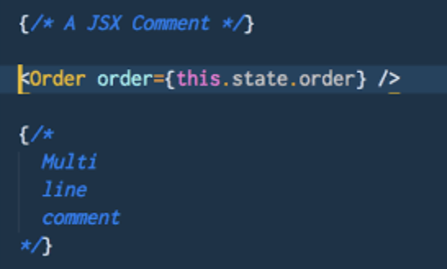

**5. What is <React.Fragment><React.Fragment/> and <></>?**

Both are same.

JSX can have only one root (parent)

React.Fragment is a comp that is exported by react

<div></div> — adds a div / space

<React.Fragment></React.Fragment> ◊ To aviod extra div / space

<></> === <React.Fragment></React.Fragment>

**6. What is Virtual DOM?**

Virtual DOM ◊ Representation of actual DOM

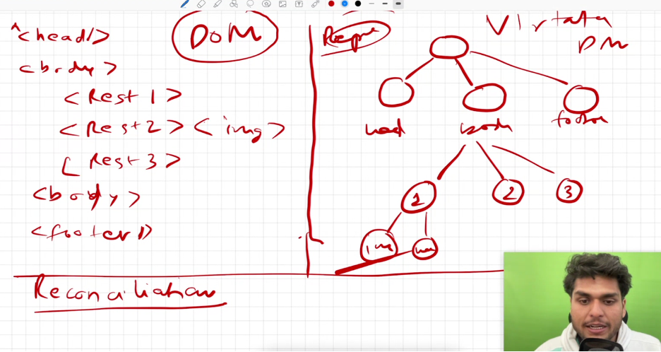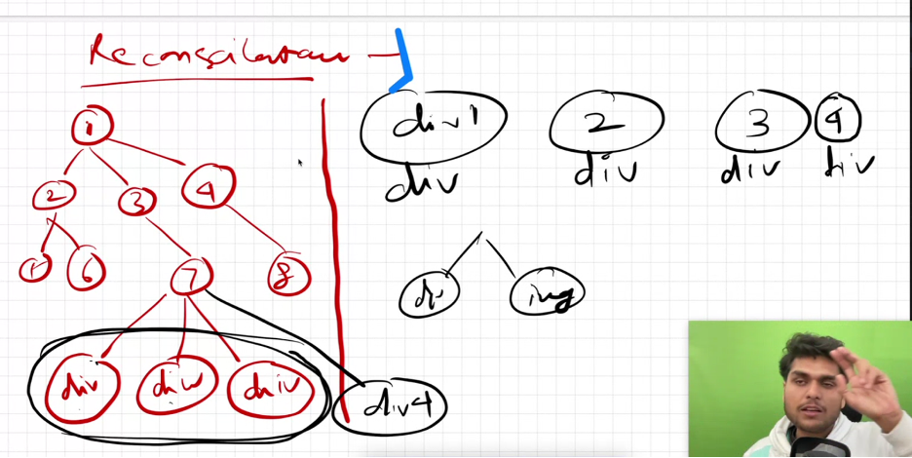

**7. Why we need reconciliation ?**

Reconciliation algorithm to diff one tree from another (diff algorithm)

Diff algorithm finds out what has changed and re renders only that.

Multiple children with same attribute eg) only div ◊ react does not know which div was new. So the diff algorithm re renders everything

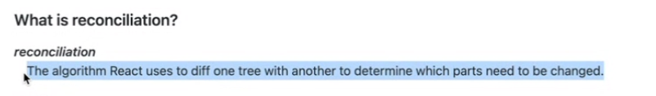

**8. What is react fiber?**

React Fiber is **a concept of ReactJS that is used to render a system faster and smoother**. React is one of the popular JavaScript library used to create a responsive user interface.

**9. Why we need keys in React? Why do we need keys in React?**

If key is used ◊ key is unique. It re renders the new div only.

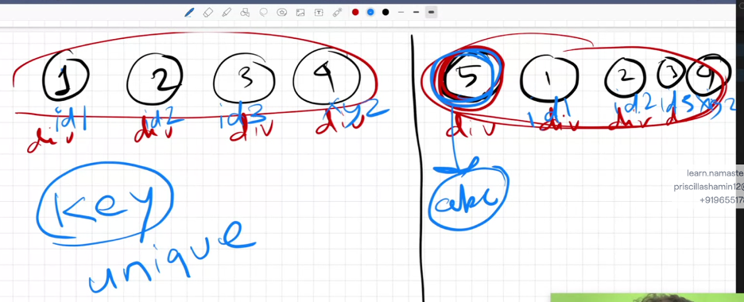

**10. Can we use index as keys in React?**

Yes, But that is not the best procedure

No key (not acceptable) <<<<<<<<<< index key (use only if no unique key) << unique key (best practice)

**11. What is props in React?**

Pass Properties — pass data into component (functional / class comp)

**12. What is Config Driven UI?**

When you build a real time website, we cant have a different ui based on location. So BE gives data based on location.

Backend controls what needs to be shown in the UI

**13. Why react is fast?**

It finds the difference between virtual DOM and real DOM

React uses one-way data binding and virtual DOM, whereas Angular uses two-way data binding and real DOM. Moreover, React is faster than Angular as **it has a smaller bundle size**.